# **What is Power BI?**

## Power BI is a collection of software services, apps, and connectors that work together to turn your unrelated sources of data into coherent, visually immersive, and interactive insights. Your data might be an Excel spreadsheet, or a collection of cloud-based and on-premises hybrid data warehouses. Power BI lets you easily connect to your data sources, visualize and discover what's important, and share that with anyone or everyone you want.

More info -->link

## **The parts of Power BI**

Power BI consists of several elements that all work together, starting with these three basics:

 Power BI Desktop.

Power BI service.

Power BI Mobile apps

# **What is Power BI Desktop?**

Power BI Desktop is a business intelligence tool developed by Microsoft that enables users to create interactive visualizations and reports with data from various sources. It allows users to connect, transform, and visualize data through a drag-and-drop interface without needing to write any code.

With Power BI Desktop, users can create and customize charts, tables, and other visualizations to present their data in a way that is easy to understand and analyze. The tool also provides advanced features for data modeling, such as calculated columns and measures, and supports a wide range of data sources including Excel spreadsheets, databases, and cloud services like Azure SQL Database and Amazon Redshift.

Users can also publish their reports and visualizations to the Power BI service, where they can be shared with others in their organization or accessed on the web and through mobile devices. Power BI Desktop is a powerful and versatile tool for data analysis and visualization that is widely used in business, finance, and other industries.

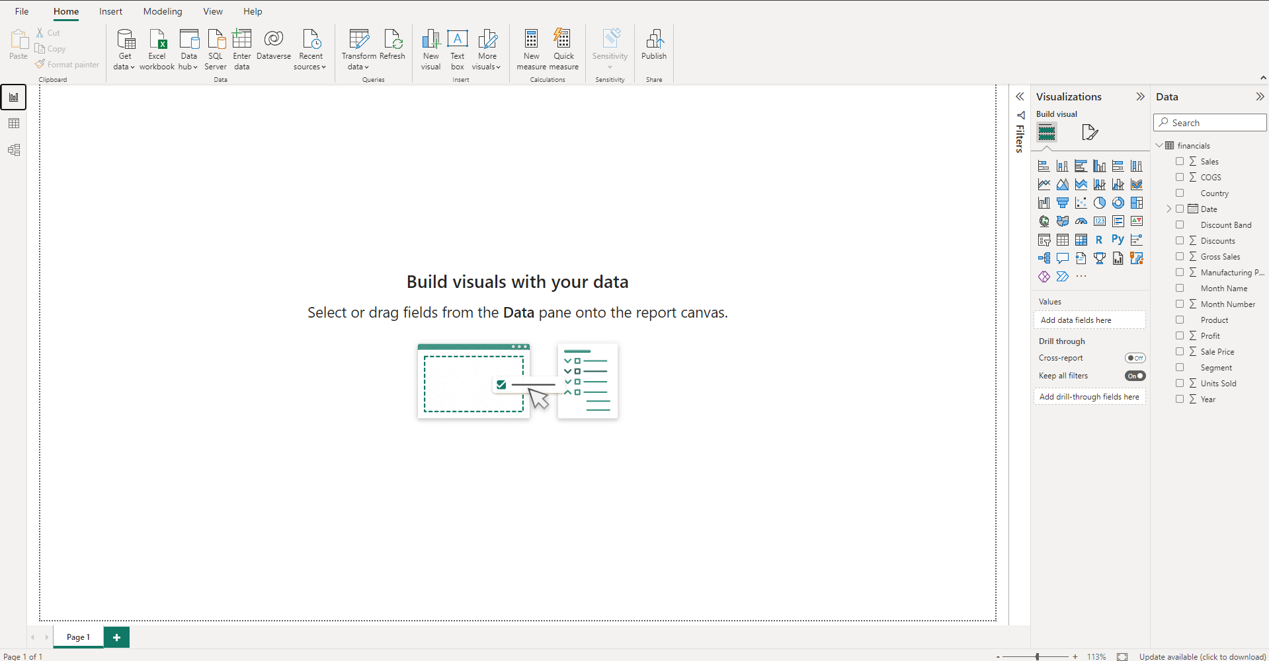

Note:

Power BI Desktop is updated and released on a monthly basis, incorporating customer feedback and new features. Only the most recent version of Power BI Desktop is supported.

The most common uses of power BI.

* Data analysis and visualization
* Business intelligence reporting:
* Data modeling and transformation:
* Collaboration and sharing:
* Mobile reporting:

# **What is the Power BI service?**

Power BI is a collection of software services, apps, and connectors that work together to help you create, share, and consume business insights in the way that serves you and your business most effectively. The Microsoft Power BI service (https://app.powerbi.com), sometimes referred to as Power BI online, is the software as a service (SaaS) part of Power BI. In the Power BI service, dashboards help you keep a finger on the pulse of your business. Dashboards display tiles, which you can select to open reports for exploring further. Dashboards and reports connect to datasets that bring all of the relevant data together in one place.

Beyond those three, Power BI also features two other elements:

****Power BI Report Builder****

****Power BI Report Serve****

## **The flow of work in Power BI**

One common workflow in Power BI begins by connecting to data sources in Power BI Desktop and building a report. You then publish that report from Power BI Desktop to the Power BI service, and share it so business users in the Power BI service and on mobile devices can view and interact with the report.

This workflow is common, and shows how the three main Power BI elements complement one another.

****When you start learning power bi you must focus on the main features given below:****

* Data modeling: Understanding how to create a data model in Power BI is crucial for building accurate and efficient reports. This involves importing data from various sources, creating relationships between tables, and defining calculated columns and measures.
* Sharing and collaboration: Power BI allows you to share your reports and dashboards with others within your organization or externally. You need to learn how to publish your reports to the Power BI service, set up permissions and security, and collaborate with others on the same report.
* Advanced features: Power BI has many advanced features that can help you take your reporting and analysis to the next level, such as data analysis with AI, custom visuals, and embedding reports in other applications.
* Data transformation: Power BI has a variety of data transformation tools that allow you to clean and manipulate data, such as merging tables, filtering, sorting, and grouping data, and creating custom columns.
* DAX language: DAX (Data Analysis Expressions) is a powerful formula language used in Power BI for creating custom calculations and measures. It is essential to learn the syntax and functions of DAX to build complex calculations.
* Visualization: Power BI provides a variety of visualization options, such as charts, tables, matrices, and maps, that can help you convey your data insights effectively. It is important to learn how to choose the right visualizations and customize them to fit your needs.

These are the main functionalities or working of power bi.